### **Project Proposal: Sweet Delights Bakery System**

#### **1. Introduction**

The Sweet Delights Bakery System is designed to streamline operations and enhance customer engagement for our local bakery. The system includes modules for order management, inventory management, customer interaction, user authentication, and reporting.

#### **2. System Components**

* **Order Management:** Customers can place orders through the graphical user interface (GUI). The system will process and manage these orders, providing real-time updates to both customers and bakery staff.
* **Inventory Management:** The system will keep track of bakery inventory, automatically updating as orders are fulfilled and new stock is added. Alerts will notify staff when inventory is low.
* **Customer Interaction:** The GUI will allow customers to create accounts, track orders, and provide feedback. The system will store customer information securely.
* **User Authentication:** Staff and customers will have secure login credentials to access the system. Different access levels will be implemented for staff and customers.
* **Reporting:** The system will generate reports on sales, inventory status, and customer feedback. These reports will aid in decision-making and business analysis.

#### **3. System Architecture**

The system will be built in Python, utilizing a graphical user-friendly interface created with a library such as Tkinter. Three main classes will be implemented:

1. **UserManager:** Manages user accounts, handles authentication, and stores customer information securely.
2. **InventoryManager:** Tracks bakery inventory, sends alerts for low stock, and updates inventory based on order fulfillment.
3. **OrderManager:** Manages incoming orders, updates inventory, and communicates order status to customers.

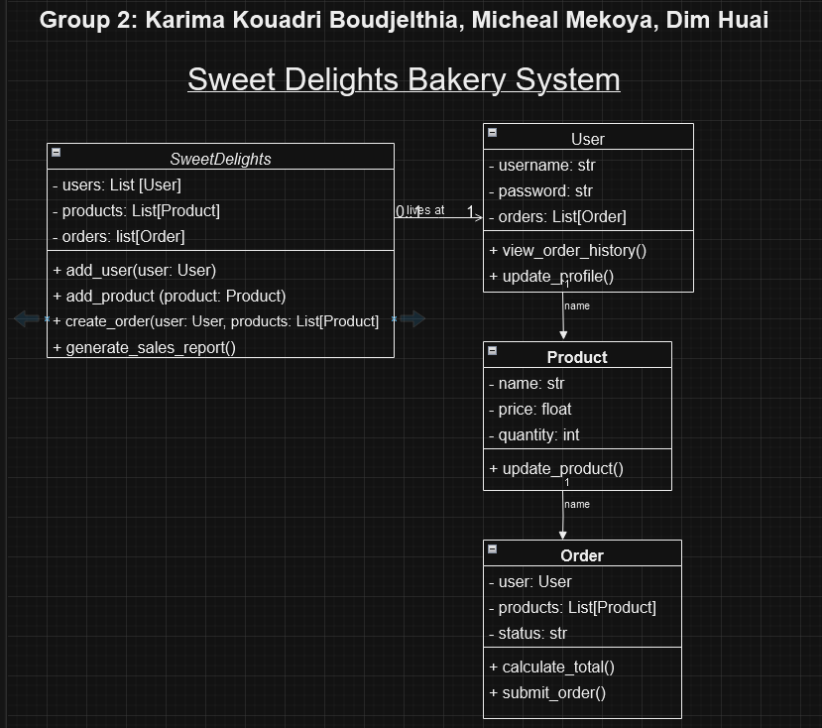

#### **4. Utilized Collections**

The system will make extensive use of Python collections:

* **Lists:** To store and manage orders, inventory items, and customer information.
* **Dictionaries:** For efficient lookup and retrieval of data, such as user credentials.

#### **5. Code Management and Collaboration**

* **Kanban Boards:** We will use Trello to manage our project with a Kanban board, providing a visual representation of tasks, progress, and deadlines.
* **GitHub Repositories:** Our code will be hosted on GitHub, ensuring version control and collaboration. The repository will be accessible to both team members and the instructor.

#### **6. Team Roles and Communication**

* **Project Manager: Karima Kouadri Boudjelthia**
* Responsible for overall project coordination, goal setting, and ensuring project milestones are achieved.
* **Front-End Developer: Micheal Mekoy**
* Designs the user interface and implements front-end features for a seamless customer experience.
* **Back-End Developer and Designer: Dim Huai**
* Manages server-side logic, database management, and focuses on creating visual elements.
* **Quality Assurance Tester: Karima Kouadri Boudjelthia**
* Ensures the system functions correctly, conducts testing, and identifies and resolves any bugs or issues.
* **Documentation Specialist: Dim Huai**
* Keeps project documentation up-to-date, including the proposal, class diagram, and reports.

**7. Communication Plan:**

* **Primary Communication Tool:** Discord - Dedicated server for team discussions, text and voice chats, file sharing, and chat logs.
* **Weekly Meetings:** Zoom- we have a plan Schedule One a week for real-time progress discussions, issue resolution, and planning.
* **Asynchronous Communication:**  Utilizing - Discord for ongoing updates, discussions, and file sharing outside of scheduled meetings.

#### **8. Evaluation and Feedback**

* **Evaluation:** Team members will be evaluated based on their contributions to the project. The team leader will provide updates on individual progress during weekly meetings.
* **Feedback:** Regular feedback sessions will be conducted, and team members will provide input on each other's contributions. This feedback will be shared with the instructor for evaluation.

#### **9. Documentation**

The project documentation will include:

* **Proposal:** Outlining the system's purpose, components, and architecture.
* **Class Diagram:** Illustrating the relationships between the three main classes.
* **Report of Results:** Providing a summary of system functionality, along with sample output.

#### **10. Submission**

The project leader will provide updates in the comments area, including:

* **Trello Board URL**
* **GitHub Repository URL**
* **Additional Comments**

**Note:** The proposal will be reviewed by the instructor, and only upon acceptance can the team proceed with the project.